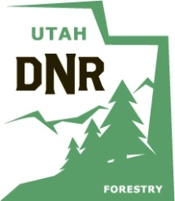 | APPLICATION  UTAH DIVISION OF FORESTRY, FIRE AND STATE LANDS  2014 BEACH LAUNCHING PERMIT  for sovereign lands at Bear Lake

Landowner Name (according to county records):
(please print)

I HEREBY CERTIFY that I am the owner of or designated representative for the below-referenced property at Bear Lake. If not the recorded landowner, list name and relationship to landowner.

Applicant Name:

If not the county-recorded owner, relationship to owner:

Applicant’s Home Address:*

City: State: Zip:

*Permits to be sent here? Yes No, send to:

Bear Lake Street Address: City:

Home Phone: Bear Lake Phone:

Quagga Mussel Decontamination Certification Number ________________________________

I FURTHER CERTIFY that by obtaining this beach launching permit that I will obey all laws and regulations pertaining to the use of sovereign lands, and I will educate my guests on same laws and regulations, including but not limited to:

- Must display use permit on launching vehicle.
- This authorization is only to launch vessels. Please take launching vehicle onto private property after vessel is launched.
- Camping & use of motorized vehicles are prohibited between the hours of 10 pm – 7 am.
- No campfires or fireworks are allowed.

Signature: Date:

